**COVID 19, THE DEBT OF THE HUMANITY WITH THE CIVILIZATORY PROCESS**

**Antônio Domingos Araújo Cunha [1]**

**ABSTRACT**

This article has the aim to discuss and address the vulnerability of two systems observed nowadays, where changing ideas, is as a matter of fact an important right, while individual conscience for mere convenience, sometimes does not match with a collective purpose, or vice versa. The author of this article wants to prove that the division between the public and the private has been difficult to be traced. The dynamic of social relationships places humanity tied to those aspects like power and alterity, with expectations of solutions to emerging problems, such as the evolution of biological threats that are in need to be questioned, like COVID 19 pandemic situation.[2] A cause-effect relationship of systems provokes reflection about the path of humanity. An overwhelming threat in the evolution of harmful beings to human nature creates opportunities for all of us to contemplate the forces that regulate our civilizational process, along the time.

**RESUMO**

Este artículo tiene como objetivo discutir y abordar la vulnerabilidad de los sistemas tan presentes en los tiempos contemporáneos, donde cambiar de opinión es un derecho, mientras que la conciencia individual por conveniencia a menudo no rastrea el propósito con el colectivo, o viceversa. El autor de este artículo quiere creer que la línea divisoria entre lo público y lo privado nunca ha sido más difícil de trazar. La dinámica de las relaciones sociales coloca a la humanidad atada a vínculos de poder y alteridad, donde las expectativas de soluciones a problemas emergentes, como la evolución de las amenazas biológicas, comienzan a cuestionarse, como COVID 19. La relación causa-efecto de los choques sistémicos da lugar a la reflexión sobre el progreso de la humanidad. La abrumadora amenaza en la evolución de los seres nocivos para la naturaleza humana genera oportunidades para contemplar las fuerzas que regulan el proceso civilizador, en la línea de tiempo.

**Keywords:** COVID- 19. Policies. Public and Private Interests. Threats. Rights.

02

**INTRODUCTION**

Some hard moments in the history of human civilization process could be observed along the centuries like Indian and Afro descendent prosecution, the Black Plague,[3] the two World Wars, with the Spanish Flue in 1918 and the unforgettable invasion provoked by military exercises in Hiroshima and Nagasaqui, which provoked massive population elimination, Nazism and the Holocaust, HIV and Ebola virus, besides yellow fever, Chikungunya , Zyca virus, Dengue, Meningitis in 1970 decade, [4] that can be resumed in some words: empowerment, human exploitation, and casual natural occurrences, provoked by chemical, physical or biological disasters, considering sociocultural influences, mainly uncontrollable strategies which require knowledge, and educational background. Welcome to the first new greatest threat of the new millennium: COVID 19, which requires public defense and private social cooperation.[5]

#### 03

#### The aim of this article is to register the first impressions of the pandemic situation, considering the intranational relations, and main facts in the first global general conscious of the contamination danger throughout the world. The author has observed Social Media behavior specially Facebook and Google reports for 15 days since the worldwide problem has broken up the rhythm of social life of the humanity. Associations with specific bibliography and concerns were stablished considering the paper of governments regulating peoples’ behavior and the so complex asymmetries of sociolegal systems on treating the problems due to the demands of strategic planning on the way to control the situation. Frontiers were never before more observed after the COVID 19 spread.

#### In this sense, soft law as UDHR[6] in Article 13 mentions:  (1) Everyone has the right to freedom of movement and residence within the borders of each state. (2) Everyone has the right to leave any country, including his own, and to return to his country. A huge gold cage had opened the doors. Every single door of a family territory has stablished overlaps of possible contamination. The world was all alerted to a security state, by the communitarian transmission of COVID 19, like the gradual reduction of freedom since March 19th, 2020 in our town, Curitiba, with echoes of increasing confirmed cases throughout the world.

The problem seems to start with the unforbidden consuming Chinese cultural background to include exotic food in their everyday diet, like bats. They have been pointed as the intermediate host of Covid 19. There are rumors of international conflicts, considering the two week silent period [7] of Chinese authorities to the worldwide community in order to develop and apply strategic measures to combat the massive contamination with the application of sanitary procedures and international security. China has recovered the control so fast, by applying sanitary strategies however, the authorities unconsidered the so fast social dynamic relations, mainly the frontiers. By the moment it is out of question, it was not a manipulated process.[8]

We all could observe the increasing progress of biological weapons and the so present possibility of human genocide. Another important icon about the question is

04

due to consider if COVID 19 was accidentally incorporated as a threat to humans or, it was an exercise to figure out strategies to future more and more delicate situations like what is being observed with the challenge to combat this virus in the first months of 2020. A global awareness to all of us! Is it a cultural problem or a diffuse strategy? The first rumor of original intermediate virus host was an animal. How can Chinese sanitary policies permit the process of special exotic food, without contemplating the risk to consumers? China has banned the trade of wildlife, suspecting that exotic animals infected humans. What will that really do? By the other side, Pangolin is known as a Malaysian most trafficked mammal in the world credit animal that is ordered as a delicacy as well as for medicinal virtues of their scales, however, it has come to public to prevent the population about the risks of eating wildlife animals. Corona Virus has been transmitted to humans via a wild animal for sale [at a wet market in Wuhan](https://www.businessinsider.com/wuhan-coronavirus-chinese-wet-market-photos-2020-1), a city in central China, which is being announced to be unlocked down the end of March, in case of severe sanitary measures. China has had wildlife trading bans on the books for three decades, but those haven’t prevented pangolins from becoming the most trafficked mammal in the world,[9] and many other exotic animals included in the Chinese cuisine menu, like bats. Vulnerable spaces are now elective, like homes, hospitals or any other confined one. Some symptomatic evidences like tiny respiratory droplets while someone coughs or sneezes out or touches a contaminated surface and self directs it to his or her face can be indicated as the mechanism of transmission. The problem in Brazil is now concentrated in the obligation of the state to control H1N1 flue, which can easily engage people to hospital condition, The first week of sanitary measures, included elderly people as prior as well as health professional people. Neither in private nor public authorized places of distribution was the vaccine found after the first days of the procedures. Besides this, mask production process was prior to hospitals and its use was questionable by the society in terms of necessity. And besides this alcohol was not on the shelves anymore. And much more than this, many producers managed ethanol fraudulently inspiring social policies and penalties to dealers. There is also a lack of testing kits or because many asymptomatic people are wearing it while not able to be tasted.

As it was already said, the spread of the virus contamination has different angles of analysis. It is absolutely incredible how the pandemic crisis was put under control in China as well as it was rapidly controlled in Russia. Cuba has learnt something about this process as well in case of economic relationship and common interest in the production of pharmacological products. By the moment, t[he first testing in humans of an experimental vaccine began in mid-March.](https://www.nytimes.com/2020/03/19/us/politics/coronavirus-vaccine-competition.html?action=click&pgtype=Article&state=default&module=styln-coronavirus-markets&variant=show&region=BELOW_MAIN_CONTENT&context=storyline_faq) Such rapid

05

development of a potential vaccine is unprecedented, but even if it is proved safe and effective, it probably will not be available for 12 to18 months.

The fact is that the world is divided in blocks, and the communist one affects directly the capitalist way of living, mainly the USA. In this sense Dr. Anthony Fauci, the administration’s most outspoken advocate of emergency virus measures in the USA, adverts to a torrent of false claims that he is mobilizing to undermine Donald Trump, about possible fake news and a directed email, and ironically the USA has reached the strongest level of contamination as it can be seen in a constant update site covering all the curiosities concerning the statistics and quantitative results. [10]

**1. A general view of the global and the local, figuring out how the virus has been spread**

We are almost 8 billion people in the world. Many people are passing away this life considering many reasons, like: transmissivity of illnesses, neoplastic disease, smoking and alcohol addiction, HIV, Traffic accidents, suicides, Yellow Fever, reaching a daily mark of 159.800 people.[11] Though, natural cycle of life, like: birth, raising, reproduction, and death are expected stages of any of us. Not all of us can really be blessed to overcome all these stages. In this sense, many influences will determine the quality and longevity of our lives. Cultural and social background as well as self-insertion can influence and determine so much the success or not of an individual for the community.

The author presents the arrival of the pandemic COVID 19 in his town, Curitiba, which has been pointed out as a model in terms of Urban Planning Management, having seen it was its cultural ethnographic background, the main inspiration for his final Master Degree research concerning cultural policies. [12] In Brazil, the number of cases reaches more than four thousand cases, mainly in Rio de Janeiro and São Paulo. They are both considered global megalopolis. The number of cases is discrete by the moment. 148 cases in Paraná State and more than 50% of them in the Capital, Curitiba, by the moment.[13]

06

**Picture 01 Picture 02 Picture 03**

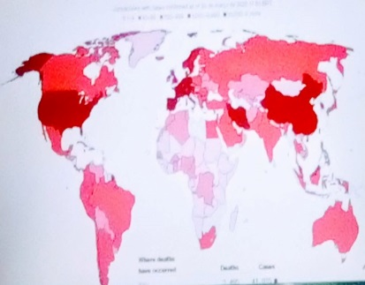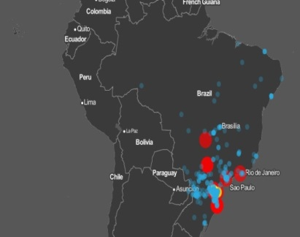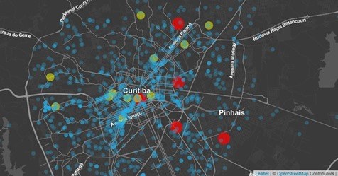

# Source: Picture 01. Evaluable at: <GENERAL MAP VIEW. Evaluable at: <https://www.bloomberg.com/graphics/2020-wuhan-novel-coronavirus-outbreak/?fbclid=IwAR37X42QG8Pz-K4AwDSdJ2mWe1xme28XL-JEGwSFuus1wyYm0Wrfg0DwWnc>> Date: March 21st, 2020.

**Pictures 02 and 03. Evaluable at** :< <https://ricmais.com.br/noticias/estudante-de-medicina-da-ufpr-cria-sistema-que-mostra-evolucao-do-coronavirus-no-brasil/?fbclid=IwAR28iFfK-hJhqOItCx4ZJ4QN9AQgROFfFJws5I-dt9xKs7xjucX3vnOr20.cuU>> Date: March 21st, 2020.

**2. The production of massive contamination weapons against solutions to them**

An interesting web comment was reported concerning the possibility to modify and create lethal viruses, capable of becoming biological weapons, like smallpox. Imagine a lethal virus like HIV, or COVID 19 or anyone that spreads easily like the flu, being manipulated and introduced in the planet. It sounds fiction, but it is now a real possibility. Unlike it was thought, COVID 19 is contaminating rare cases of babies and animals, although there are cases being announced, especially domestic ones, including rare children confirmation. As it was said by the geneticists: If nature doesn't produce one on its own, we can do it on our own. The possibility of combining genetic engineering with the arsenal of terrorist organizations is more than speculation. With today's technology, one can make terrible viruses using their genetic code.

To prove it works, researchers at New York University created a new polio virus from scratch. “Our work serves as proof of what can be done”, said Jeronimo Cello, one of the authors of the research who replied: … when an arming can be done someone ends up doing it.[14]

In counterpoint position, which is also remarkable, a country from Central America is top list in the solution of the problem with strong economic interests with China. So far, as it was reported, it is known that ‘Interferon alfa 2B’ may have helped the recovery of more than 1,500 patients, as it is one of 30 drugs chosen by the

07

Chinese National Health Commission to cure the respiratory condition. "The interferon alfa 2B has the advantage that, in situations like this, it is a mechanism to protect itself. Its use prevents patients with the possibility of aggravating and complicating it from reaching this stage and, finally, have death as a result", said Luis Herrera Martínez, scientific and commercial consultant for the BioCubaFarma business group. The BioCubaFarma group is also working on a project to develop a Cuban antiviral, cigb 210, as well as a vaccine candidate to submit it to China for consideration, in addition to quick strips for diagnosing the disease.[15]

We have to observe that none of the Central America countries are included in the top list continental contamination and some correlations should be observed considering the demonstrated control of the pandemic alarm and the measures adopted either.

### 3. The perspective of the problem in everyday life. The lockdown period

In moments of tension as an epidemic crisis that we are experiencing due to coronaviruses, as people tend to soften more, because the uncertainties about the disease, and the social isolation for prevention just ended up making us more fragile. Those who have already been diagnosed with some mental disorder, such as Obsessive Compulsive Disorder (OCD), to depression and anxiety, are more subject to suffer with demonstration of crises. OCD is marked, in general, by a series of habits executed constantly and involuntarily. Secondly, as the psychologist Flávio Luiz Gomes mentions, some theorists treat this illness that tends to be compulsory, even if it perceives prevention only. Normally you are engaged in the areas of cleanliness, checking out contagious explanations about contamination, systemic organization, and data symmetry and collecting. The dimension of the disorder can vary to the length of the evolution of symptoms as well as the sensibility of each patient. We also have to mention de cases of claustrophobia. Many people are getting depressive to be locked at home, because of the disease itself, and many of them are not resisting the familiar tension in terms of familiar relationships. [16] The increasing utilization of social nets and means of communication is more than never in evidence. The cities and communities

08

are being connected with the weakness of face to face relationships as well as people do have much more time to explore the vast territory of virtual space.

The fact is that the lockdown period does not match too much with the expected social behavior. Urban life has been presented now as a global most empty outside vast territory. Anyway, people are constantly moving along the streets and also tried to get the roads to the coasts like a long vacation period exactly when the virus was coming from the back door of our State. A socioeconomic crisis is knocking on our frontal doors and nobody knows how the silent took place in most of the cities. This is a unique moment in everyday life in this planet. It sounds that the entire environment will take a breath. In the roots of the problem, it is much more a cultural problem rather than an exercise of war. It affects almost 200 countries. Many of them have declared State of Emergency, like ours and have adhered to quarantine as a strategy. However, it is weird that Chinese people came back to the attitude to eat bats as it is being reported in the social media, after such a terrible cause-effect relation which provoked the global pandemic crisis. There are rumors of Penal and Civil evoked responsibilities and it is just the embryonic stage of a long demand of Public and Private International Law conflicts, and territorial reinvention of insiders and outsiders, no matter the nationality of each one, contaminated or not. The millennium starts with a huge challenge: Overcoming an incomparable traumatic experience for all of us.

**Picture 04 Picture 05**

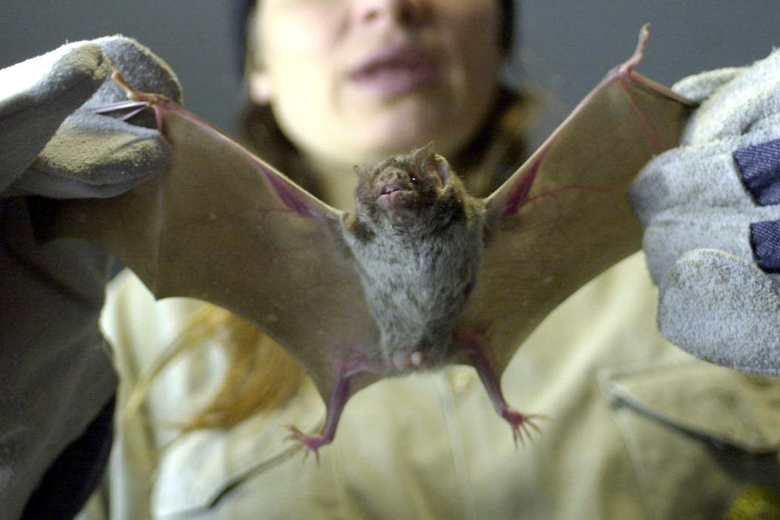 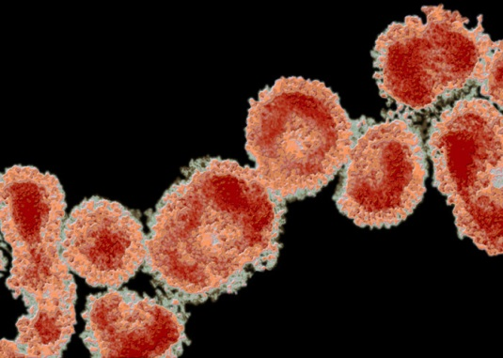

**Source:** Evaluable at: VOLVIO LA VENTA DE CARNE DE MURCIELAGOS EN CHINA < [https://www.lanacion.com.ar/el-mundo/coronavirus-segun-diario-ingles-mercados-chinos-siguen nid2348579?utm_medium=Echobox&utm_source=Facebook&fbclid=IwAR3HMKqivoLPrSNqCCtRopwZlb78_YKtXkmlqaLPDpEfn9q6NY0PciDgnFo#Echobox=1585501373](https://www.lanacion.com.ar/el-mundo/coronavirus-segun-diario-ingles-mercados-chinos-siguen%20nid2348579?utm_medium=Echobox&utm_source=Facebook&fbclid=IwAR3HMKqivoLPrSNqCCtRopwZlb78_YKtXkmlqaLPDpEfn9q6NY0PciDgnFo#Echobox=1585501373)> Date. MARCH 30TH, 2020.

**Source:** Photo: Dr. F.A. Murphy/Getty Images/Visuals Unlimited INTELLIGENCER. By Jeff Wise. Evaluable at: < <https://nymag.com/intelligencer/2020/03/the-story-of-a-coronavirus-infection.html?fbclid=IwAR2k-Pl-y74mxQyHGRqdxxO8GoM7XbNYR52etjC2uieDYDKv9D3Q7K1NPs4>> Date: March 18th, 2020.

09

**4. What we learn with the problem, and how it changes the global conscious**

We do start to recognize equality as a main value. Happiness is what reaches the majority of people. Utilitarian measures where adopted in order to avoid local and

imported transmission, although it is not out of question. People are being asked to join the aim of eradication or at least, hold control of the situation. We also have a possibility of increasing rates of marginality and social crimes, having seen the normal tension in the familiar environment.[17] What are the social changes that will be observed in the next days since the virus became the greatest threat for all of us? Even the Olympic Games were postponed for the next year, once it should put in risk the athletes as well as the global organization. All the scenarios of the world are being constantly changed. The market is being transformed and priorities to supply chain are being a must nowadays in Brazil. Industries are almost closing the doors, and reinventing their potential capacity to produce what governments are asking, like masks and fans for medical use.[18] Many restrictive measures are being adopted and imposed by policies, like the control of abusive price imposed to consumers. Countries started to flatten the curves of COVID 19 occurrences while some ones are just starting to raise them. Solidarity and International Relationships have been observed between countries. But also, offenses of governments to one each other, like it was noticed between China and Brazil. Transparence of government’s investments are being questioned in Brazil, with the public television announcement of the President Jair Bolsonaro evoking the population to stop quarantine when it is being announced as an international requirement of the Global Health Institutions. In comparison with the devastation of some cities where tourism is the main form of transmition, Italy has learnt a hard lesson [19] and also Spain. The fact is only this scenario of fear of contamination can change the destination of future medical cases.

10

The spread of COVID-19 points to Global TOTAL Deaths: 26.943 confirmed cases: 590,254; 176 countries; US Total deaths 1544 in 50 states, with 100,717 cases by the moment (Updated as of March 27, 2020 at 5:00 pm EST.) [20] Lukashenko from Belarus, is one more president mocking the rest of the world, calling everyone psychotic, and this report became viral. [21]

The author also considers very relevant, the number of students who look for the High Standards of International Education in the US. This country remains the top host of international students globally. International students made a significant financial impact on the United States in 2017, contributing $42.4 billion to the U.S. economy through tuition, room and board, and other expenses, according to the U.S. Department of Commerce. Once the communities are locked down how will the government manage such interests? [22] Although, it is not only a problem of this country but also of many ones who are exploring education as business rather than a right of any local institution mainly because of the accreditation of national institutions as well as access to Education. The author has been advocating in this sense in the PhD final research project, for years. As a matter of fact, virtual education cannot substitute the uncomfortable situation of millions of teenagers and youngsters, arrested on their homes and depending on their parents’ incomes, more than never. Before COVID 19, we had a huge number of teens and youngsters living in such precarious conditions of life, children labor exploitation, school abandonment, starvation and health care, sexual and drug involvements. Or else, the neglect of their Social Rights or precariously attended. How will it be, after COVID 19? And during? As a professor for so many years, I can try to answer this question. There is no effective platform of virtual spaces to coordinate Long Distance Education in public education in Brazil, and schools are working to distribute only the food it was supplied for the families, protected by social support. It sounds that the greatest perspective of future generation now, is the renascence of the planet. Even the ozone layer is changing colors and being revitalized.

11

**Picture 06**

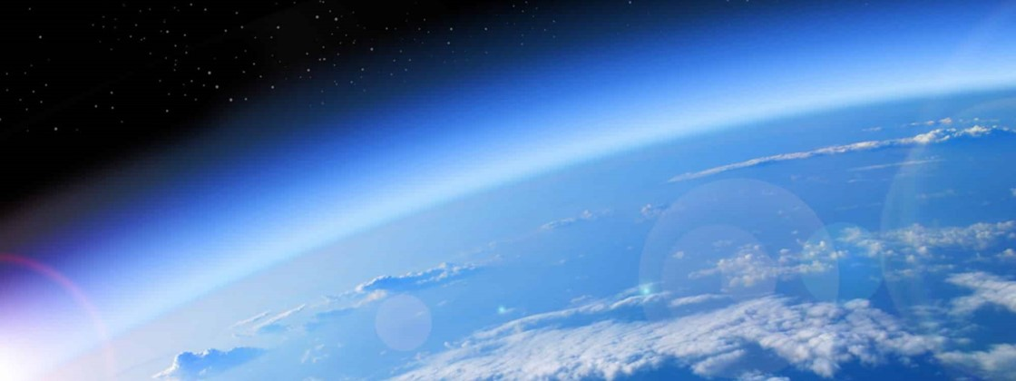

**Source:** Environmental Reversion of the Planet …. <<https://www.nytimes.com/2020/03/28/technology/coronavirus-fauci-trump-conspiracy-target.html?referringSource=articleShare&fbclid=IwAR14usAQHTkv4S-UI6LYq8J_FZ-njLNeJ-C3h6QsvYDrbZMF_7xK7-pVw0Y>> Date: March 30th, 202

**CONCLUSION**

The presence of the virus is breaking down some paradigmatic conditions, like the facility of dissemination considering transportation. How will means of transportation be managed to control massive occupation from now on? It is the concept of safety that is being put in evidence. That will provoke such uncomfortable and tragic evolution of millions of people in hospitals or death. The transmition is now communitarian. It is hard to identify the origin of the transmission. What anyone can really do is to reinforce personal protection what implies in much more costs for related goods and reinvention of priorities in terms of consume, which is being creatively motivated in our communities, with the proposal of sustainable models. It is hard to contemplate consequences, mainly Civil and Penal responsibilities. At the first moments of the pandemic spread, Brazilian people emerged in confusion, moving horizontally to the beaches for example, trying to escape from urban conurbation, migrating to the coast in the south of Brazil. It is not vacation time! Frontiers were blocked not regionally but also internationally. Restrictive measures are being asked and many of them were interdicted as well as the roads and the use of means of public transportation as it was said above. People got desperate stocking groceries at home in case of a breakdown supermarket supplement chain.

A massive communication process is being activated in Brazilian main television channels so that people can be informed about the progress of the situation provoked by COVID 19. Once the temples were closed the dynamic of social nets are increasing

12

sensibly. It should be considered a support to such period where people are all submerged into deep depression, not only because of the threat to be contaminated but also to be exposed to reclusion for such a long time and the loss of references, like community contact, intellectual routines in schools and universities, and mainly, economic support which is provided by labor exercise. We also have an explosion of people circulating in the streets and each citizen has an argument. What argument will we all have when it becomes uncontrollable? The rules include firstly, keeping a certain distance, secondly social isolation and also, the use of military forces to control movement in the streets. But, after two weeks, it sounds that the lesson was given. There is no space in the hospitals and enough supplements of medical care to answer diligently to all the demands which means, anyone no matter the economic status or social position is vulnerable to hospital environment. Staying at home is compromising familiar budgement, and provoking a revolution in terms of contracts, credit cards, financial familiar savings, inheritance and properties management, informal labor market relations, and much more.

Besides observed measures taken by the governments and protection to abuse o contractual clauses, a strong task force is being demanded in terms of providing assistance to contaminated people as well as medication and accommodations to so many citizens, medicines and equipment too. We also have the clinical support not well protected to the necessary exposition in the combating areas.[23] Logistics in this sense is fundamental. If Hospital supplies do not reach the consumers – medical care professional – patients will not be safe as OMS announces. We are now facing the quarantine period in its second week. It sounds that nations are all transferring the responsibility to the state. Welfare State System is back to the international governments as a must to correct the strongest strike we have all seen in the world with the spreading contamination of COVID 19.

It is already proved we are all physical energy, and it is material and projected. All the bombastic exposition to information is really interfering in our spiritual connection with our physical body, because of fear. It reduces our basic psychics’ to such a condition of fragilities. In this time of quarantines we are all preserving and reinforcing our convictions and selecting priorities. What is really urgent now is the sense of love. It is just the first call of the forces surrounding us. Our unique performance in the planet! Live longer! Take care! Conscious and citizenship!

13

**REFERENCES**

34 YEARS OLD NURSE DANIELA TRESI COMMITS SUICIDE IN MONZA, ITALY CONTAMINATED IN HER JOB. Evaluable at: < [https://english.alarabiya.net/en/features/2020/03/29/italian-nurse-commits-suicide-over-fears-of-spreading-coronavirus.html](https://english.alarabiya.net/en/features/2020/03/29/Italian-nurse-commits-suicide-over-fears-of-spreading-coronavirus.html)> Date: 29.03.2020. Evaluable at: < https://english.alarabiya.net/en/features/2020/03/29/italian-nurse-commits-suicide-over-fears-of-spreading-coronavirus.html> date: 29.03.2020. Degree thesis evaluable at: <<https://administradores.com.br/producao-academica/politicas-publicas-culturais-em-face-a-pluralidade-etnica-em-curitiba>> date: March 30th, 2020.

INTERNATIONAL STUDENTS IN THE USA. Evaluable at: <<https://ng.usembassy.gov/number-of-international-students-in-united-states-reaches-new-high-of-1-09-million/>> Date: March 30th, 2020.

CORONAVIRUS IS PSYCHOSIS. Evaluable at: < <https://www.washingtonpost.com/world/europe/no-lockdown-here-belaruss-strongman-rejects-coronavirus-risks-he-suggests-saunas-and-vodka/2020/03/27/7aab812c-7025-11ea-a156-0048b62cdb51_story.html>> Date: March 30th, 2020.

COVID 19 MILLION DEATHS WITHOUT ACTION EVALUABLE AT: <https://www.businessinsider.com/coronavirus-uk-report-projects-2-million-deaths-without-action-2020-3> DATE: March 30th, 2020.

.

34 YEARS OLD NURSE DANIELA TRESI COMMITS SUICIDE IN MONZA, ITALY CONTAMINATED IN HER JOB. Evaluable at: < <https://english.alarabiya.net/en/features/2020/03/29/Italian-nurse-commits-suicide-over-fears-of-spreading-coronavirus.html>> Date: March 29th, 2020.

CORONA VÍRUS NÃO FOI CRIADO EM LABORATÓRIO. [https://oglobo.globo.com/sociedade/coronavirus-servico/estudo-descarta-hipotese-de-que-novo-coronavirus-tenha-sido-criado-em-laboratorio 24317110?utm_source=Facebook&fbclid=IwAR1Hnsw_xk4CzfHdeR_36G0uHowq5c0cdT2jQq7LTtrNdduONTRARyCjYJs](https://oglobo.globo.com/sociedade/coronavirus-servico/estudo-descarta-hipotese-de-que-novo-coronavirus-tenha-sido-criado-em-laboratorio%2024317110?utm_source=Facebook&fbclid=IwAR1Hnsw_xk4CzfHdeR_36G0uHowq5c0cdT2jQq7LTtrNdduONTRARyCjYJs)

CUBA ACTING TO COMBAT DE VIRUS. Evaluable at: < <https://dialogosdosul.operamundi.uol.com.br/saude/63492/as-acoes-de-cuba-diante-do-avanco-mundial-do-novo-coronavirus>. Date: March 29th, 2020.

14

Dr. F.A. Murphy/Getty Images/Visuals Unlimited INTELLIGENCER. By Jeff Wise. Evaluable at: < <https://nymag.com/intelligencer/2020/03/the-story-of-a-coronavirus-infection.html?fbclid=IwAR2k-Pl-y74mxQyHGRqdxxO8GoM7XbNYR52etjC2uieDYDKv9D3Q7K1NPs4>> Date: March 18th, 2020.

ENVIRONMENTAL REVERSION OF THE PLANET …. <<https://www.nytimes.com/2020/03/28/technology/coronavirus-fauci-trump-conspiracy-target.html?referringSource=articleShare&fbclid=IwAR14usAQHTkv4S-UI6LYq8J_FZ-njLNeJ-C3h6QsvYDrbZMF_7xK7-pVw0Y>> Date: March 30th, 2020.

EVOLUTION OF CORONA VIRUS IN BRAZIL < Evaluable at: <https://ricmais.com.br/noticias/estudante-de-medicina-da-ufpr-cria-sistema-que-mostra-evolucao-do-coronavirus-no-brasil/?fbclid=IwAR28iFfK-hJhqOItCx4ZJ4QN9AQgROFfFJws5I-dt9xKs7xjucX3vnOr20.cuU>> Date: March 21st, 2020

# GENERAL MAP VIEW. Evaluable at: <<https://www.bloomberg.com/graphics/2020-wuhan-novel-coronavirus-outbreak/?fbclid=IwAR37X42QG8Pz-K4AwDSdJ2mWe1xme28XL-JEGwSFuus1wyYm0Wrfg0DwWnc>> Date: March 21st, 2020.

# Jerônimo Cello. Evaluable at: < <https://www1.folha.uol.com.br/fsp/ciencia/fe1207200205.htm>> Date: March 31st, 2020.

MAYOR OMITS INFORMATION IN WOHAN <https://oglobo.globo.com/sociedade/saude/prefeito-de-wuhan-admite-ter-omitido-informacoes-sobre-coronavirus-oferece-renuncia-24213420?fbclid=IwAR2NJdoWSrpBDBrviSAs3u1qwmqQohQfKC3EUtXKCuF0XO9XoUFS4vZfzvo>

# MENINGITIS IN BRAZIL Evaluable at: <<https://noticias.r7.com/brasil/em-carta-aberta-china-oferece-ajuda-ao-brasil-contra-o-coronavirus-27032020>> Date: March 29th, 2020.

PANGOLIN CORONAVIRUS: REVENGE OF THE PANGOLINS? Evaluable at :< <https://www.nytimes.com/2020/03/05/opinion/coronavirus-china-pangolins.html>> Date: March 20th, *2020.*

15

PEOPLE WITH TOC CAN SUFFER MORE WITH CORONAVÍRUS 19 Evaluable at: < [https://www.soubh.com.br/noticias/viva-bem/pessoas-com-toc-depressao-e-ansiedade-podem-sofrer-mais-durante-a quarentena?fbclid=IwAR3LL_jPHODKabw3Yj76PqkxT6PGQ_aPqQpBjbLaBQk9AeJ_Ov-cnQNFNAI](https://www.soubh.com.br/noticias/viva-bem/pessoas-com-toc-depressao-e-ansiedade-podem-sofrer-mais-durante-a%20quarentena?fbclid=IwAR3LL_jPHODKabw3Yj76PqkxT6PGQ_aPqQpBjbLaBQk9AeJ_Ov-cnQNFNAI)> Date: March 24th, 2020.

# PUBLIC AND PRIVATE RIGHTS IN THE FORESHORE. Evaluable at: < <https://www.jstor.org/stable/1112734?seq=1#metadata_info_tab_contents>> Date: March 30th, 2020.

THE BLACK DEATH EVALUABLE AT: < <https://en.wikipedia.org/wiki/Black_Death>> Date: March 20th, 2020.

THE MISTAKE TO HAVE FORGOTTEN THE THIRD SECTOR. Evaluable at :< <http://www.vita.it/it/article/2020/03/25/zamagni-coronavirus-che-errore-aver-dimenticato-il-terzo-settore/154638/?fbclid=IwAR18ATs7xBAhWfA4QcmD__68Z2hzGxEwBirxgtoX-6gg8DpjWSuzCm3uM7k>> Date: MARCH 25TH, 2020

UNIVERSAL DECLARATION OF HUMAN RIGHTS. Evaluable at: <https://www.un.org/en/universal-declaration-human-rights/>> Date: March 30th, 2020.

USA ESTIMATION OF CONTAMINATION Evaluable at: < <https://brasil.elpais.com/internacional/2020-03-29/epidemiologista-da-casa-branca-calcula-que-eua-poderao-ter-200000-mortes-por-coronavirus.html>> Date: March 20th, 2020.

VOLVIO LA VENTA DE CARNE DE MURCIELAGOS EN CHINA < [https://www.lanacion.com.ar/el-mundo/coronavirus-segun-diario-ingles-mercados-chinos-siguen nid2348579?utm_medium=Echobox&utm_source=Facebook&fbclid=IwAR3HMKqivoLPrSNqCCtRopwZlb78_YKtXkmlqaLPDpEfn9q6NY0PciDgnFo#Echobox=1585501373](https://www.lanacion.com.ar/el-mundo/coronavirus-segun-diario-ingles-mercados-chinos-siguen%20nid2348579?utm_medium=Echobox&utm_source=Facebook&fbclid=IwAR3HMKqivoLPrSNqCCtRopwZlb78_YKtXkmlqaLPDpEfn9q6NY0PciDgnFo#Echobox=1585501373)> Date. MARCH 30TH, 2020.

WHO IS GOING TO TAKE CARE OF THE KIDS? Evaluable at< [https://nacoesunidas.org/covid-19-criancas-enfrentam-ris…/…/](https://nacoesunidas.org/covid-19-criancas-enfrentam-risco-maior-de-abuso-e-negligencia-em-meio-a-medidas-de-contencao/amp/?fbclid=IwAR0BoBFrv5nleNZ1DGREoRJ2a01QZXSXN_r_WYIeXfD2yySBP-XnqEe1Ksc)> Date: March 24th, 2020

1. * Higher Education Professor, Law, Business and Natural Science Graduate Courses, Urban Planning Master Degree, PhD Candidate on Civil Law, Facultad de Derecho de la Universidad de Buenos Aires – Argentina, Summer Extension Course at “The Hague Academy of International Law”, Netherlands, 2015, Public and Private International Law Credits. Extension - Public Policy Challenges of the 21st Century – Virginia University – USA – APRIL - 2020.

  
2. Common to all the nations … “a worldwide spread of a new disease.”
3. The Black Death, also known as the Pestilence, Great Bubonic Plague, the Great Plague or the Plague, or less commonly the Great Mortality or the Black Plague, was one of the most devastating [pandemics](https://en.wikipedia.org/wiki/Pandemic) in human history, resulting in the deaths of an estimated 75 to 200 million people in Eurasia, peaking in Europe from 1347 to 1351.[[1]](https://en.wikipedia.org/wiki/Black_Death#cite_note-ABC/Reuters-1)[[2]](https://en.wikipedia.org/wiki/Black_Death#cite_note-Health:_De-coding_the_Black_Death-2)[[3]](https://en.wikipedia.org/wiki/Black_Death#cite_note-Black_Death's_Gene_Code_Cracked-3) The [bacterium](https://en.wikipedia.org/wiki/Bacteria) [*Yersinia pestis*](https://en.wikipedia.org/wiki/Yersinia_pestis), which results in several forms of [plague](https://en.wikipedia.org/wiki/Plague_(disease)) (septicemic, pneumonic and, the most common, bubonic), is believed to have been the cause.[[4]](https://en.wikipedia.org/wiki/Black_Death#cite_note-4) The Black Death was the first major European outbreak of plague and the [second plague pandemic](https://en.wikipedia.org/wiki/Second_plague_pandemic).[[5]](https://en.wikipedia.org/wiki/Black_Death#cite_note-5) The plague created a number of religious, social and economic upheavals, with profound effects on the course of European history. The Black Death probably originated in Central Asia or East Asia, from where it travelled along the [Silk Road](https://en.wikipedia.org/wiki/Silk_Road), reaching [Crimea](https://en.wikipedia.org/wiki/Crimea) by 1343.[[11]](https://en.wikipedia.org/wiki/Black_Death#cite_note-11) From there, it was most likely carried by [fleas](https://en.wikipedia.org/wiki/Oriental_rat_flea) living on the [black rats](https://en.wikipedia.org/wiki/Black_rat) that traveled on [Genoese](https://en.wikipedia.org/wiki/Republic_of_Genoa) merchant ships, spreading throughout the Mediterranean Basin, reaching the rest of Europe via the Italian peninsula. The Black Death is estimated to have killed 30% to 60% of Europe's population.[[12]](https://en.wikipedia.org/wiki/Black_Death#cite_note-12) In total, the plague may have reduced the [world population](https://en.wikipedia.org/wiki/World_population) from an estimated 475 million to 350–375 million in the 14th century.[[13]](https://en.wikipedia.org/wiki/Black_Death#cite_note-13) It took 200 years for Europe's population to recover to its previous level, and some regions (such as [Florence](https://en.wikipedia.org/wiki/Florence)) only recovered by the 19th century.  The plague recurred as outbreaks until the early 20th century. Evaluable at: < <https://en.wikipedia.org/wiki/Black_Death>> Date: March 20th, 2020.

   # 4 MENINGITIS IN BRAZIL Evaluable at: <<https://noticias.r7.com/brasil/em-carta-aberta-china-oferece-ajuda-ao-brasil-contra-o-coronavirus-27032020>> Date: 29.03.2020

  
4.
5. # *Jus publicum and jus privatum*. Recommended reading. Public and Private Rights in the Foreshore

   Evaluable at: < <https://www.jstor.org/stable/1112734?seq=1#metadata_info_tab_contents>> Dates: March 30th, 2020.
6. UNIVERSAL DECLARATION OF HUMAN RIGHTS. Evaluable at: <https://www.un.org/en/universal-declaration-human-rights/>> Date: March 30th, 2020.
7. OMISSION OF CHINESE AUTHOORITY. Evaluable at: < <https://oglobo.globo.com/sociedade/saude/prefeito-de-wuhan-admite-ter-omitido-informacoes-sobre-coronavirus-oferece-renuncia-24213420?fbclid=IwAR2NJdoWSrpBDBrviSAs3u1qwmqQohQfKC3EUtXKCuF0XO9XoUFS4vZfzvo>> Date March 20th, 2020.
8. CORONA VÍRUS NÃO FOI CRIADO EM LABORATÓRIO. Evaluable at: <[https://oglobo.globo.com/sociedade/coronavirus-servico/estudo-descarta-hipotese-de-que-novo-coronavirus-tenha-sido-criado-em-laboratorio 24317110?utm_source=Facebook&fbclid=IwAR1Hnsw_xk4CzfHdeR_36G0uHowq5c0cdT2jQq7LTtrNdduONTRARyCjYJs](https://oglobo.globo.com/sociedade/coronavirus-servico/estudo-descarta-hipotese-de-que-novo-coronavirus-tenha-sido-criado-em-laboratorio%2024317110?utm_source=Facebook&fbclid=IwAR1Hnsw_xk4CzfHdeR_36G0uHowq5c0cdT2jQq7LTtrNdduONTRARyCjYJs)> Date: March 20th, 2020.
9. 9.  Pangolin Coronavirus: Revenge of the Pangolins? Evaluable at :< <https://www.nytimes.com/2020/03/05/opinion/coronavirus-china-pangolins.html>> Date: March 20th, *2020.*
10. WHITE HOUSE. Evaluable at: < <https://brasil.elpais.com/internacional/2020-03-29/epidemiologista-da-casa-branca-calcula-que-eua-poderao-ter-200000-mortes-por-coronavirus.html>> Date: March 20th, 2020.
11. SOURCE: INDEXMUNDI/ WORLDMETERS
12. COVID IN BRAZIL. Evaluable at: <<https://administradores.com.br/producao-academica/politicas-publicas-culturais-em-face-a-pluralidade-etnica-em-curitiba>> Date: 30.03.2020.
13. BRAZILIAN PANDEMIC CONTROL Evaluable at: < <https://www.saude.gov.br/noticias/agencia-saude/46619-brasil-registra-4-256-casos-confirmados-de-coronavirus-e-136-mortes>> Date: March 30th, 2020.
14. Jerônimo Cello. Evaluable at: < <https://www1.folha.uol.com.br/fsp/ciencia/fe1207200205.htm>> Date: March 31st, 2020.
15. Evaluable at: < <https://dialogosdosul.operamundi.uol.com.br/saude/63492/as-acoes-de-cuba-diante-do-avanco-mundial-do-novo-coronavirus>. Date: March 29th, 2020.
16. ## People with TOC can suffer more with CORONAVÍRUS 19 Evaluable at: < [https://www.soubh.com.br/noticias/viva-bem/pessoas-com-toc-depressao-e-ansiedade-podem-sofrer-mais-durante-a quarentena?fbclid=IwAR3LL_jPHODKabw3Yj76PqkxT6PGQ_aPqQpBjbLaBQk9AeJ_Ov-cnQNFNAI](https://www.soubh.com.br/noticias/viva-bem/pessoas-com-toc-depressao-e-ansiedade-podem-sofrer-mais-durante-a%20quarentena?fbclid=IwAR3LL_jPHODKabw3Yj76PqkxT6PGQ_aPqQpBjbLaBQk9AeJ_Ov-cnQNFNAI)> Date: March 24th, 2020.

   
17. Who is going to take care of the kids? Evaluable at< [https://nacoesunidas.org/covid-19-criancas-enfrentam-ris…/…/](https://nacoesunidas.org/covid-19-criancas-enfrentam-risco-maior-de-abuso-e-negligencia-em-meio-a-medidas-de-contencao/amp/?fbclid=IwAR0BoBFrv5nleNZ1DGREoRJ2a01QZXSXN_r_WYIeXfD2yySBP-XnqEe1Ksc)> Date: March 24th, 2020.
18. (PPE) Personal Protective Equipment (PPE)
19. THE MISTAKE TO HAVE FORGOTTEN THE THIRD SECTOR. Evaluable at :< [http://www.vita.it/it/article/2020/03/25/zamagni-coronavirus-che-errore-aver-dimenticato-il-terzo settore/154638/?fbclid=IwAR18ATs7xBAhWfA4QcmD__68Z2hzGxEwBirxgtoX-6gg8DpjWSuzCm3uM7k](http://www.vita.it/it/article/2020/03/25/zamagni-coronavirus-che-errore-aver-dimenticato-il-terzo%20settore/154638/?fbclid=IwAR18ATs7xBAhWfA4QcmD__68Z2hzGxEwBirxgtoX-6gg8DpjWSuzCm3uM7k)> Date: MARCH 25TH, 2020. As it was mentioned: It is evident and also quite right that the various fundraising campaigns are now and in the near future to support the sector of our healthcare structures, whose shortcomings have emerged on the surface in this crisis. We must therefore expect a heavy displacement effect to the detriment of Third Sector entities. The destruction or even the decrease in our share capital that would ensue would be a real disaster Id. Ib.
20. EVALUABLE AT: <https://www.businessinsider.com/coronavirus-uk-report-projects-2-million-deaths-without-action-2020-3> DATE: March 3oth, 2020.
21. CORONAVIRUS IS PSYCHOSIS. Evaluable at: < <https://www.washingtonpost.com/world/europe/no-lockdown-here-belaruss-strongman-rejects-coronavirus-risks-he-suggests-saunas-and-vodka/2020/03/27/7aab812c-7025-11ea-a156-0048b62cdb51_story.html>> Date: March 30th, 2020.
22. Evaluable at: <<https://ng.usembassy.gov/number-of-international-students-in-united-states-reaches-new-high-of-1-09-million/>> Date: MARCH 30TH, 2020.
23. 34 years old Nurse Daniela Tresi commits suicide in Monza, Italy contaminated in her job Evaluable at: < <https://english.alarabiya.net/en/features/2020/03/29/Italian-nurse-commits-suicide-over-fears-of-spreading-coronavirus.html>> Date: 29.03.2020.